MODEL FEATURE SELECTION
-- Feature Selection is where we turn our EDA findings into a clean set of variables for the ML model.
-- But creating a feature doesn't automatically mean we should keep the original variables and every derived variable together.
-- The first thing we need to do is prevent data leakage.

2.6.1. Separate application-time features from leakage
-- We can also the application-time features as predictive features.
-- Application time features are the features the model will use to predict whether a borrower is likely to default on a loan during the application process/time.
-- Our model is supposed to answer "Given what we know when a borrower applies for a loan, how likely are they to default?"
-- Therefore, we should only use information available at or before the loan application.

Remove these from the predictive features
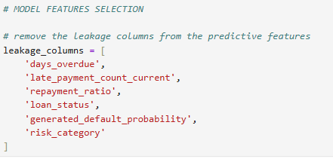

2.6.2. Remove the target
-- Obviously, default itself cannot be an input.
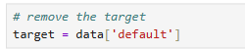
-- Our model will eventually learn x = predictor variables/columns and y = target

2.6.3. Remove the ID
-- If your dataset contains an identifier such as ID column, we shouldn't use it as a predictor either.An ID identifies a borrower/application; it doesn't represent a meaningful credit characteristic.

2.6.4 CREATE OUR INITIAL FEATURE SET
-- Let's explicitly create the application-time variables/ prediction variables rather than simply throwing every column into the model.
-- Our model application_time/ prediction variables/columns will be divided into five categories:
Borrower profile: age, employment_type, county, membership_years
Financial capacity: monthly_income_kes, savings_balance_kes, other_monthly_debt_kes, avg_monthly_inflows_kes, avg_monthly_outflows_kes
Loan characteristics: loan_product, loan_amount_kes, loan_term_months, monthly_repayment_kes
Previous credit history: previous_loans, previous_defaults, previous_late_payments.
Financial/digital behavior: mobile_money_active_months, utility_payment_consistency, income_consistency_score.
Engineered features: loan_to_income_ratio, debt_to_income_ratio, total_debt_service_ratio, monthly_cash_flow, cash_flow_to_income_ratio, repayment_to_income_ratio, savings_to_income_ratio
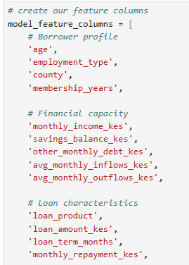
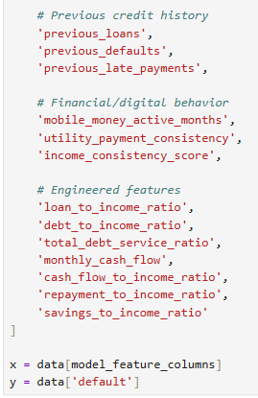

-- Check it:
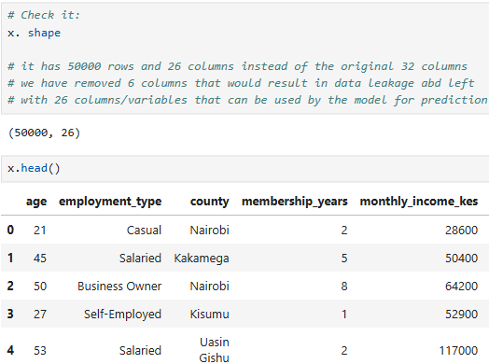

2.6.5 One important question: application_date
-- We haven't included application_date yet because A raw date isn't directly meaningful to most of our first models.
-- However, the date can potentially be transformed into useful features, such as application_month, application_year, day_of_week.
-- But we don't necessarily need these unless there is a business reason or evidence of temporal patterns. For our first credit-risk model, we'll leave the raw date out.

2.6.6 Now check correlations among numerical model features.
-- So the next step is simply look at the correlation matrix → identify strongly overlapping features → decide which feature among the overlapping features is the most useful for the model.
-- For our project, we're especially going to examine the relationships among
- debt_to_income_ratio
- repayment_to_income_ratio
- total_debt_service_ratio
because we already know they're mathematically related. They are very likely to give almost the same information(overlap) and if all are used by the model, it will create a problem called multicollinearity for the model(the model finding it difficult to decide which feature among the overlapping features to use in prediction).
-- So we'll examine the actual correlation matrix for the numerical model features first and then decide
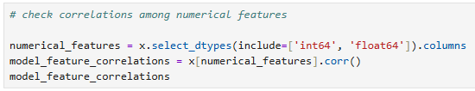

-- What are we looking for? We're particularly interested in correlations close to:
- +1 → very strong positive relationship(an increase in one feature leads to an increase in another feature)
- 0 → little linear relationship(an increase or decrease in one feature does not affect the other feature at all)
- -1 → very strong negative relationship( an increase in one feature leads to a decrease in the other feature)

2.6.7 Don't automatically remove highly correlated features
-- This is an important ML lesson
-- If you find Feature A ↔ Feature B = 0.85, don't immediately delete one
-- For Logistic Regression, multicollinearity can make coefficients harder to interpret and less stable.
-- MULTICOLLINEARITY IS HAVING TWO OR MORE FEATURES TELLING YOU THE SAME INFROMATION(overlapping) AND THEREFORE FINDING IT DIFFICULT TO DETERMINE WHAT FEATURE TO GIVE THE HIGHEST PRIORITY / HOW MUCH IMPORTANCE TO ASSIGN TO EACH PERSON'S STATEMENT INDIVIDUALLY.
-- Multicollinearity doesn't necessarily mean The model can't predict. It mainly creates problems when we want to interpret the individual Logistic Regression coefficients.That's why we'll check correlations before building our Logistic Regression model

-- Think of multicollinearity as having two columns that are telling the model almost the same story. Suppose we give Logistic Regression these two features
monthly_income = KES 50,000
annual_income = KES 600,000
-- These contain essentially the same information. Because annual income divided by number of months gives monthly income directly.
-- Or in our project
- debt_to_income_ratio
- repayment_to_income_ratio
- total_debt_to_income_ratio
-- Remember total_debt_to_income_ratio is basically the combination of the other two. So these features overlap.
-- Overlapping features are features that essentially contain the same information.
Why is OVERLAPPING a problem for Logistic Regression?
-- Logistic Regression tries to calculate a coefficient for each feature.
-- For example, it might produce
- loan_to_income +0.8
- savings_to_income -0.6
- debt_to_income +0.3
-- The coefficient tells us how that feature is associated with the predicted probability of default while accounting for the other features.
-- But if two or more features contain almost the same information, the model can have trouble deciding: Which feature should get the credit for this relationship?
-- It might give one feature a large coefficient and another a small coefficient.Or, with small changes in the data, the coefficients can change considerably.That's what we mean by less stable coefficients.
-- Imagine three people telling a manager "The borrower has a high debt burden." Person A says it. Person B says almost exactly the same thing. Person C says the same thing in slightly different words.
-- The manager now has difficulty determining how much importance to assign to each person's statement individually. But the overall message is still clear: The borrower has high debt burden.That's similar to multicollinearity.
-- Multicollinearity doesn't necessarily mean The model can't predict. It mainly creates problems when we want to interpret the individual Logistic Regression coefficients. That's why we'll check correlations before building our Logistic Regression model.
-- Looking at the correlation matrix, there are several important multicollinearity relationships we should address before Logistic Regression.
Feature pair | Correlation | What it means
total_debt_service_ratio ↔ repayment_to_income_ratio | 0.986 | Almost the same information
membership_years ↔ mobile_money_active_months | 0.975 | Almost the same information
avg_monthly_inflows_kes ↔ avg_monthly_outflows_kes | 0.967 | Very strongly related
monthly_income_kes ↔ avg_monthly_inflows_kes | 0.956 | Strong overlap
monthly_income_kes ↔ avg_monthly_outflows_kes | 0.925 | Strong overlap
monthly_repayment_kes ↔ repayment_to_income_ratio | 0.832 | Strong relationship
monthly_repayment_kes ↔ total_debt_service_ratio | 0.820 | Strong relationship
membership_years ↔ previous_loans | 0.796 | Strong relationship
monthly_income_kes ↔ loan_amount_kes | 0.767 | Strong relationship
monthly_cash_flow ↔ cash_flow_to_income_ratio | 0.705 | Strong relationship
other_monthly_debt_kes ↔ debt_to_income_ratio | 0.692 | Expected because the ratio uses debt
savings_balance_kes ↔ savings_to_income_ratio | 0.684 | Expected because the ratio uses savings

-- The most important one: 0.986: total_debt_service_ratio and repayment_to_income_ratio have correlation 0.986. That's extremely high. And there's a mathematical reason:
total_debt_service_ratio =
debt_to_income_ratio + repayment_to_income_ratio

-- So these aren't just coincidentally correlated—they are built from overlapping information. For Logistic Regression, keeping both can make it difficult to interpret their individual coefficients.

membership vs mobile-money activity
membership_years = 0.975 = mobile_money_active_months
-- These two variables are essentially telling the model very similar information in this dataset.We should probably keep one rather than both.However, we shouldn't automatically delete one just because the correlation is high. We should consider the business meaning too.
-- For example:
membership_years → relationship with the SACCO
mobile_money_active_months → digital financial activity
-- Those could represent different business concepts even though they're highly correlated in this synthetic dataset.

Income, inflows and outflows
-- These three variables contain substantial overlapping information.

monthly_income
↕ 0.956
avg_monthly_inflows

avg_monthly_inflows
↕ 0.967
avg_monthly_outflows

monthly_income
↕ 0.925
avg_monthly_outflows

-- But there's an important distinction:
monthly_income_kes = stated/estimated income
avg_monthly_inflows_kes = actual money coming into the account
avg_monthly_outflows_kes = actual money leaving the account

-- For a credit-risk project, these can have different business meanings even when statistically correlated. So I wouldn't blindly remove them yet.
-- ENGINEERED FEATURES NATURALLY CREATE CORRELATIONS

So what should we do now?
-- I would not start deleting columns just from this correlation matrix.
-- We will identify feature pairs with a correlation above 0.80.

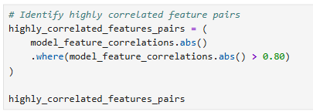

Feature 1 | Feature 2 | Correlation | What we should think about
membership_years | mobile_money_active_months | 0.975 | Very high overlap
monthly_income_kes | avg_monthly_inflows_kes | 0.956 | Very high overlap
monthly_income_kes | avg_monthly_outflows_kes | 0.925 | Very high overlap
avg_monthly_inflows_kes | avg_monthly_outflows_kes | 0.967 | Very high overlap
monthly_repayment_kes | total_debt_service_ratio | 0.820 | Strong overlap
monthly_repayment_kes | repayment_to_income_ratio | 0.832 | Strong overlap
total_debt_service_ratio | repayment_to_income_ratio | 0.986 | Extremely high; mathematically related

Group 1: total_debt_service_ratio ↔ repayment_to_income_ratio = 0.986.
-- I would not keep both for the initial Logistic Regression model.
-- Since total_debt_service_ratio captures both existing debt and the new loan repayment burden, it has a broader credit-risk interpretation. So a reasonable candidate is:
KEEP: total_debt_service_ratio
REMOVE: repayment_to_income_ratio

Group 2 — Membership vs mobile-money activity
-- membership_years and mobile_money_active_months have correlation 0.975.These are telling the model almost the same thing in this dataset. For the portfolio model, we could keep: membership_years because it directly represents the borrower's relationship with the SACCO/MFI.
-- Then remove mobile_money_active_months

Group 3 — Income, inflows and outflows
-- We have:
- monthly_income and monthly_inflows = 0.956
- monthly_income and monthly_outflows = 0.925
- monthly_inflows and monthly_outflows = 0.967

-- This is interesting because these aren't necessarily duplicates from a business perspective. They have independent definitions
- monthly_income → stated/estimated earning capacity
- avg_monthly_inflows → actual money entering the account
- avg_monthly_outflows → actual spending/cash leaving the account

-- So I wouldn't immediately remove all but one.
-- Instead, we'll later use VIF + model performance + business interpretation to decide.

Group 4 — Monthly repayment vs repayment ratios
- monthly_repayment and repayment_to_income_ratio = 0.832
- monthly_repayment and total_debt_service_ratio = 0.820
-- This makes sense because both ratios are constructed using repayment information. For example:
repayment_to_income_ratio = monthly_repayment_kes / monthly_income_kes
-- So this correlation is partly created by our feature engineering.

VIF ANALYSIS
-- Correlation answers: "Are these two variables strongly related?"
-- VIF answers: "Is this variable largely explained by the other predictor variables together?"

Step 1 — Install/import VIF

Step 2 — Select the numerical model features
-- Use the numerical features from your current x
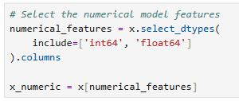

Step 3 — Calculate VIF
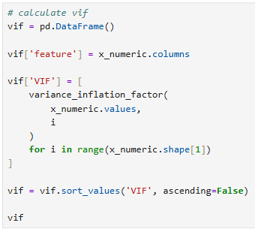
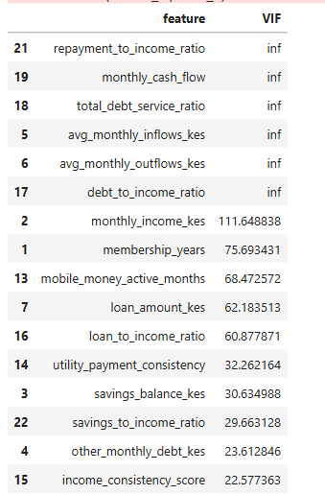
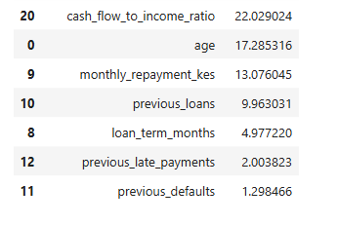

How we'll interpret it.
-- A simple rule of thumb:
VIF | Interpretation
1 | No multicollinearity
1–5 | Usually acceptable
5–10 | Potentially problematic
>10 | Strong multicollinearity

-- Because some features contain ratios constructed from other variables, expect some VIF values to be high. So don't be surprised if those variables produce very large VIFs.

Feature/group | VIF | Interpretation
repayment_to_income_ratio | ∞ | Severe multicollinearity
total_debt_service_ratio | ∞ | Severe multicollinearity
debt_to_income_ratio | ∞ | Severe multicollinearity
monthly_cash_flow | ∞ | Severe multicollinearity
avg_monthly_inflows_kes | ∞ | Severe multicollinearity
avg_monthly_outflows_kes | ∞ | Severe multicollinearity
monthly_income_kes | 111.65 | Very high
membership_years | 75.69 | Very high
mobile_money_active_months | 68.47 | Very high
loan_amount_kes | 62.18 | Very high
loan_to_income_ratio | 60.88 | Very high
utility_payment_consistency | 32.26 | Very high
savings_balance_kes | 30.63 | Very high
savings_to_income_ratio | 29.66 | Very high
other_monthly_debt_kes | 23.61 | Very high
income_consistency_score | 22.58 | Very high
cash_flow_to_income_ratio | 22.03 | Very high
age | 17.29 | High
monthly_repayment_kes | 13.08 | High
previous_loans | 9.96 | Borderline/high
loan_term_months | 4.98 | Acceptable
previous_late_payments | 2.00 | Good
previous_defaults | 1.30 | Good

-- We should not simply delete every feature with VIF > 10.
-- Your dataset contains many engineered ratios, so high VIF is expected.

WHY YOU HAVE INF VIF
-- This is particularly important for these three:
debt_to_income_ratio
repayment_to_income_ratio
total_debt_service_ratio

-- Remember how we created them:
- debt_to_income_ratio = other_monthly_debt / income
- repayment_to_income_ratio = monthly_repayment / income
- total_debt_service_ratio = (other_monthly_debt + monthly_repayment) / income

-- Therefore:
total_debt_service_ratio = debt_to_income_ratio + repayment_to_income_ratio

-- So one feature can be calculated exactly from the other two.That's why VIF becomes inf. This is perfect multicollinearity. We definitely need to remove one or more of these.For our first model, I'd use:
KEEP: total_debt_service_ratio
REMOVE: debt_to_income_ratio
REMOVE: repayment_to_income_ratio

-- Why? total_debt_service_ratio gives us a single measure of the borrower's overall monthly debt repayment burden relative to income. And your earlier analysis showed that it had a strong relationship with default.

WHY MONTHLY_CASH_FLOW HAS INFINITE VIF
-- We created
monthly_cash_flow = avg_monthly_inflows_kes - avg_monthly_outflows_kes

-- Again, it is an exact linear combination. Therefore inflows
Outflows, cash_flow cannot all be included together in a logistic regression without creating perfect multicollinearity.
-- We need to choose the representation that is most useful for the model.For a credit-risk model, cash flow itself is very interpretable.
-- So one reasonable initial choice is
KEEP: monthly_cash_flow
REMOVE: avg_monthly_inflows_kes
REMOVE: avg_monthly_outflows_kes
-- This means the model sees: How much money is left after typical monthly outflows? rather than separately seeing inflows and outflows.

MEMBERSHIP YEARS VS MOBILE-MONEY ACTIVITY
-- You have
membership_years 75.69
mobile_money_active_months 68.47
-- And their correlation was 0.9746. That's extremely high. This suggests that in this synthetic dataset Borrowers who have been SACCO members longer also tend to have been active on mobile money for longer.
-- They are therefore providing almost the same information. For the initial model, I'd keep membership_years and remove mobile_money_active_months

INCOME VS LOAN-TO-INCOME RATIO
-- You have
monthly_income_kes VIF = 111.65
loan_amount_kes VIF = 62.18
loan_to_income_ratio VIF = 60.88
-- This happens because
loan_to_income_ratio =
loan_amount / monthly_income
-- Your correlation matrix already showed
monthly_income ↔ loan_amount = 0.767
-- So we have another feature-engineering tradeoff. For credit risk, loan_to_income_ratio is often more directly interpretable: How large is the requested loan relative to the borrower's income?
-- So for the initial model, I'd consider KEEP: loan_to_income_ratio and potentially remove: monthly_income_kes and loan_amount_kes
-- But there's a caveat: income itself contains information that the ratio doesn't. A person earning KES 20,000 and borrowing KES 100,000 has the same ratio as someone earning KES 100,000 and borrowing KES 500,000. So we shouldn't automatically throw away income
-- This is exactly why feature selection should ultimately combine:
- Correlation
- VIF
- business meaning
- model performance

SAVINGS BALANCE VS SAVINGS-TO-INCOME RATIO
-- You have:
savings_balance_kes VIF = 30.63
savings_to_income_ratio VIF = 29.66
-- The ratio is savings / income
-- Your earlier bivariate analysis showed something particularly useful
Savings/income 0–100% → 29.47% default
Savings/income 300%+ → 5.72% default
-- So savings_to_income_ratio appears to provide meaningful risk segmentation in this dataset.For the first model, I'd therefore test:
KEEP: savings_to_income_ratio and remove savings_balance_kes

THE GOOD NEWS
-- These features have relatively reasonable VIF
loan_term_months 4.98
previous_late_payments 2.00
previous_defaults 1.30
-- So we don't have a multicollinearity problem with these.
-- And previous_defaults is particularly valuable from a credit-risk/business perspective because it represents historical repayment behavior.

PROPOSED FIRST MODEL FEATURE SET
-- I'd now create a reduced feature set rather than trying to eliminate everything with VIF > 10.
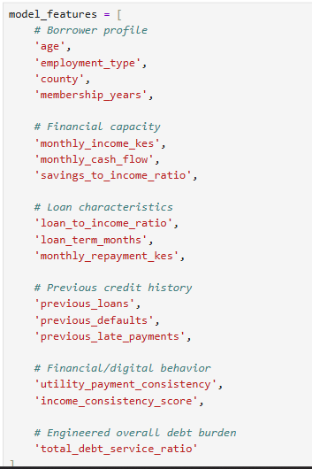
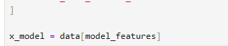

-- Notice that we've removed from the initial model
- avg_monthly_inflows_kes
- avg_monthly_outflows_kes
- mobile_money_active_months
- debt_to_income_ratio
- repayment_to_income_ratio
- savings_balance_kes
- loan_amount_kes

-- We have not permanently declared those variables useless. We're creating a cleaner baseline.

ONE MORE THING BEFORE LOGISTIC REGRESSION
-- There is something important we should do before fitting the model.
-- Our categorical variables are
employment_type
county
loan_product
-- But Logistic Regression cannot directly use strings such as:
-- We need to encode them.So the next stage is:
FEATURE SELECTION
↓
TRAIN/TEST SPLIT
↓
CATEGORICAL ENCODING
↓
NUMERICAL SCALING
↓
LOGISTIC REGRESSION

